**Hackathon 2.0**

1. **Triangles data  
   Q.1  
   Create table triangles_table**

**(Triangle int, Side_A int, Side_B int, Side_C int);**

**Insert triangles_table (Triangle, Side_A, Side_B, Side_C)values(1,20,20,23),**

**(2,20,20,20),**

**(3,20,21,22),**

**(4,13,14,30);**

**Select * from triangles_table;**

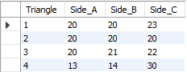

**Q.2**

**i) Select sum(Side_A) SideA_total from triangles_table;**



**ii) Select *,**

**Case**

**When Side_A=Side_B and Side_B=Side_C and Side_A=Side_C then "Equilateral"**

**else "Not Equilateral"**

**end as "Triangle type"**

**from triangles_table;**

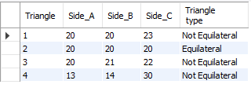

**iii) Select *,**

**Case**

**When Side_A=Side_B and Side_B!=Side_C or**

**Side_B=Side_C and Side_A!=Side_C or**

**Side_A=Side_C and Side_A!=Side_B then "Isosceles"**

**else "Not Isosceles"**

**end as "Triangle type"**

**from triangles_table;**

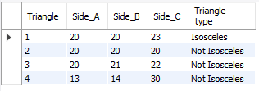

**iv) Select Count(Triangle) No_of_triangles from triangles_table;**



**v) Select Triangle, Side_B from triangles_table**

**where Triangle = 3;**



1. **Employees data**

**Q.1  
Create table Employees**

**(employee_id int, name varchar(50), months int, salary int);**

**insert Employees(employee_id, name, months, salary)values(12228,"Rahul",15,10000),**

**(33645,"Amit",1,15000),**

**(45692,"Aditi",17,18000),**

**(56188,"Pavan",11,21000);**

**Select * from Employees;**

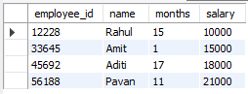

**Q.2  
i) Select Count(employee_id) Total_employees from Employees;**



**ii) Select name, salary from Employees**

**where name="Rahul";**



**iii) update Employees set months = 12**

**where name = "Amit";**

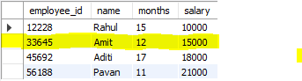

**iv) Select sum(salary) Total_salary from Employees;**



**v) Select Count(name) Names_starts_with_A from Employees**

**Where name like 'A%';**

